Project Title: Task Management System

Project Overview

Description
A Task Management System is a software application designed to help individuals and teams plan, organize, track, and complete tasks efficiently. It provides tools to create tasks, assign responsibilities, set deadlines, monitor progress, and collaborate effectively.

Purpose
The primary purpose of a Task Management System is to improve productivity and organization by providing a centralized platform where tasks can be managed transparently, prioritized, and completed on time.

Goals
- Organize Tasks: Enable users to break down work into manageable tasks and subtasks.
- Set Priorities and Deadlines: Help users prioritize work and set due dates to ensure timely completion.
- Enhance Productivity: Streamline workflows, reduce bottlenecks, and improve time management.

Key Stakeholders
User Class | Description
End Users | People who create, update, and complete tasks.  Use the system daily to organize their personal or team work.
Team Leaders | Oversee teams’ workload and progress.  Assign tasks, set priorities, and ensure deadlines are met.

Scope

In-Scope
- User management
- Task category management
- Task management
- Subtask management
- Comments on tasks

Out-of-Scope
- Collaboration with teams
- Assign users to tasks
- Share tasks to individual

User Stories/ High Level Requirements

User Stories

User Management
- As an end user, I want to create my own user account, so that I can start using the system.
- As an end user, I want to update my profile information, so that my details are accurate.
- As an end user, I want to reset my password if I forget it, so that I can regain access.
- As an end user, I want to deactivate my account if I no longer wish to use the system.

Task Category Management
- As an end user, I want to create new task categories, so that I can organize my tasks effectively.
- As an end user, I want to edit task categories I created, so that I can update their names or descriptions.
- As an end user, I want to delete task categories I created if they are no longer needed.
- As an end user, I want to filter tasks by category, so that I can focus on specific types of tasks.

Task Management
- As an end user, I want to create tasks for myself, so that I can track what I need to do.
- As an end user, I want to assign tasks to myself or other users (if applicable), so that responsibilities are clear.
- As an end user, I want to set deadlines and priorities for my tasks, so that I can manage time and importance.
- As an end user, I want to update task details like status and description, so that information stays current.
- As an end user, I want to mark tasks as completed, so that I can track progress.
- As an end user, I want to delete tasks that are no longer relevant, so that my task list stays clean.
- As an end user, I want to receive notifications or reminders about my tasks, so that I don't miss deadlines.

Subtask Management
- As an end user, I want to create subtasks under my tasks, so that I can break down work into smaller steps.
- As an end user, I want to assign subtasks to myself or others (if applicable).
- As an end user, I want to set deadlines and priorities for subtasks.
- As an end user, I want to update the status and details of subtasks.
- As an end user, I want to mark subtasks as completed.
- As an end user, I want to delete subtasks that are no longer needed.

Comments on Tasks
- As an end user, I want to add comments to my tasks, so that I can record updates or notes.
- As an end user, I want to edit my own comments to correct or add information.
- As an end user, I want to delete my own comments if they become irrelevant.
- As an end user, I want to tag other users (if multi-user) in comments to notify them.
- As an end user, I want to view all comments on a task to understand its history.

Prioritization
User story | priority
As an end user, I want to create my own user account, so that I can start using the system.
As an end user, I want to update my profile information, so that my details are accurate.
As an end user, I want to reset my password if I forget it, so that I can regain access.
As an end user, I want to deactivate my account if I no longer wish to use the system.
As an end user, I want to edit task categories I created, so that I can update their names or descriptions.
As an end user, I want to filter tasks by category, so that I can focus on specific types of tasks.
As an end user, I want to delete task categories I created if they are no longer needed.

Key Features/ Functional Requirements
- Allow users to sign up with email and password.
- Update personal details (name, email, avatar)
- Reset password via email verification.
- Allow users to deactivate/delete their account.
- Create categories with names and optional descriptions.
- Edit category details.
- Remove categories without deleting the tasks inside (optional prompt to reassign tasks).
- Filter tasks in views by category.
- Create tasks with title, description, due date, priority.
- Assign tasks to self or other users (if applicable).
- Update task details (title, description, priority, due date, category).
- Change status (Not Started, In Progress, Completed).
- Permanently remove tasks.
- Notify users of due dates, assignments, or changes.
- Create subtasks under any parent task.
- Update subtask details (title, due date, priority).
- Mark subtasks as completed or in progress.
- Remove subtasks from a task.
- Add comments to tasks.
- Edit or remove own comments.
- Mention/tag other users in comments to notify them.
- View all past comments on a task.

Non-Functional Requirements

Performance

Usability

Reliability

Security

Constraints and Standards

System Models

Use Case diagram
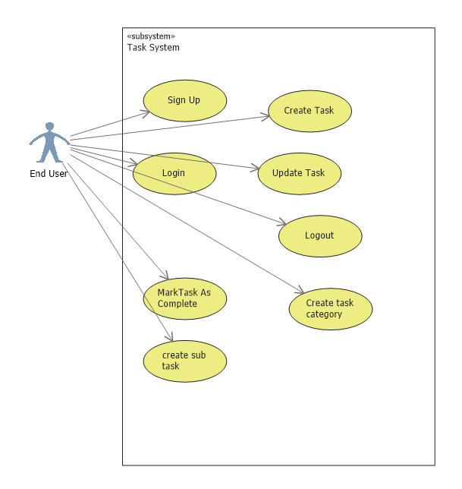

Class Diagram
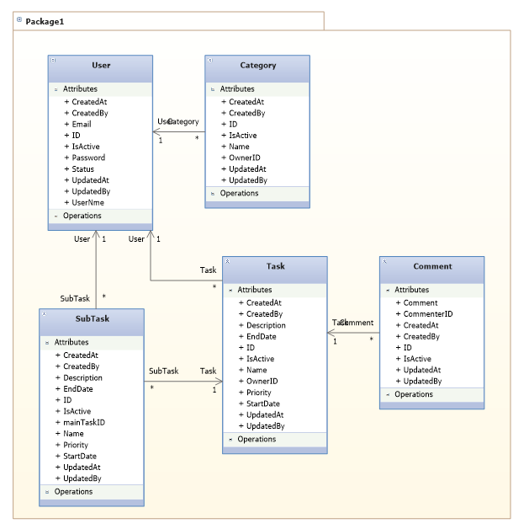

Activity Diagram

Sequence diagram

ER Diagram

Logical Schema Diagram

Data Dictionary

User
Attribute | Data Type | Description
User ID | Guid | The unique indentifer of the user
User name | varchar
Email | Varchar
passwordHash | Varchar
Status | Int

Relationship:
- User can have many tasks : 1:M

Task
Attribute | Data Type | Description
Task ID | Guid | The unique indentifer of the user
Task name | varchar
Description | Varchar
Start Date | Varchar
End Date
Status | Int
IsCompleted | Bool
Completion DAte | date
OwnerID | guid

Assumptions and Dependencies

Assumptions

Dependencies

Acceptance Criteria

User Story 1
As an end user, I want to create my own user account, so that I can start using the system.
Acceptance Criteria:
- The system provides a registration form requiring at least email and password.
- Email must be unique and validated for proper format.
- Password must meet security requirements (e.g., minimum length, complexity).
- Upon successful registration, the user receives a confirmation email.
- User cannot log in before confirming their email (optional).
- Errors are displayed clearly for invalid inputs or existing emails.

User Story 2
As an end user, I want to update my profile information, so that my details are accurate.
Acceptance Criteria:
- The user can access a profile page with editable fields (name, email, avatar, etc.).
- Changes can be saved and updated immediately upon submission.
- Validation occurs on inputs (e.g., valid email format).
- The system confirms successful update with a message.
- If email is changed, optional email verification is triggered.

User Story 3
As an end user, I want to reset my password if I forget it, so that I can regain access.
Acceptance Criteria:
- The system provides a “Forgot Password” link on the login page.
- User can request a password reset by submitting their registered email.
- The system sends a password reset link with a secure token to the user’s email.
- The reset link expires after a configurable time (e.g., 24 hours).
- User can set a new password that meets security criteria.
- Upon successful reset, the user can log in with the new password.
- Error messages are shown if email is not registered or reset link is invalid/expired.

User Story 4
As an end user, I want to deactivate my account if I no longer wish to use the system.
Acceptance Criteria:
- The user can access an option to deactivate their account from the profile settings.
- The system prompts the user to confirm deactivation to avoid accidental action.
- Upon confirmation, the account status changes to “deactivated” and user cannot log in.
- The system optionally retains user data for a defined period for reactivation (if applicable).
- The user receives a confirmation notification/email about the deactivation.
- Reactivation process (if supported) is clearly documented or accessible.

Glossary / Definitions (Optional)
Term | Definition

Typical Contents of a Lean SRS
- Project Overview
  - Brief description of the product or system.
  - Purpose and goals.
  - Key stakeholders.
- Scope
  - What the system will cover.
  - What is out of scope (optional but helpful).
- User Stories / High-Level Requirements
  - Short, clear user stories or simple requirement statements.
  - Focus on “who”, “what”, and “why”.
  - Prioritized if possible.
- Key Features / Functional Requirements
  - Main capabilities the system must provide.
  - Often described in bullet points or brief paragraphs.
  - Avoid heavy technical detail.
- Non-Functional Requirements
  - Performance expectations.
  - Usability, reliability, security basics.
  - Constraints and standards.
- Assumptions and Dependencies
  - Conditions assumed to be true.
  - External systems or components the solution depends on.
- Acceptance Criteria
  - Definition of done for each user story or feature.
  - Clear conditions to validate successful implementation.
- Glossary / Definitions (Optional)
  - Important terms and abbreviations used in the document.

